ØØ Explanation :
- We have immediate data 05 H. To load this data into the accumulator we will use the MVI A, 05 H instruction.
- To transfer the data to B register we will use the instruction MOV B, A.
- To transfer the data to H register we will use the instruction MOV H, A.
ØØ Algorithm :
Step I : Load the accumulator with immediate data 05 H
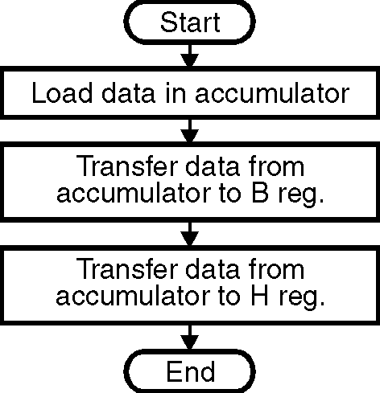
Step II : Copy the contents of accumulator to the register B.
Step III : Copy the contents of accumulator to the register H.
ØØ Flowchart : Refer flowchart 1
Program :
Instruction Comments
MVI A, 05 H ; Initialize A reg = 05 H
MOV B, A ; Transfer contents of A to B reg.
MOV H, A ; Transfer contents of A to H reg.
HLT ; Stop the execution. Flowchart 1

